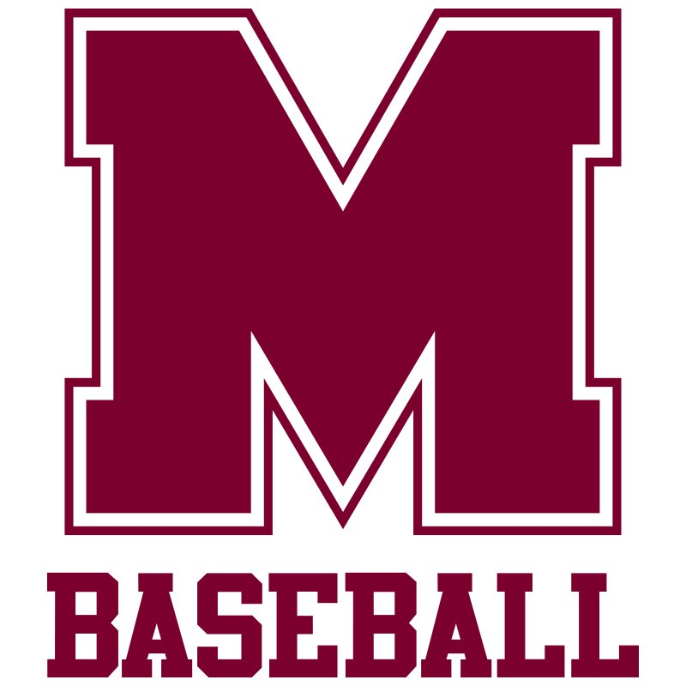

**SEASON TIMELINE**

**Tryouts:** First Week of October

**Regular Season Play:**

October & November

2 games per week,Monday & Thursday

**Postseason:** First Week of December